**RAND Survey of Firearms Experts**

(Version 4-17-20 - DRAFT)

[Programmer instructions are listed in blue. Survey respondents see all text in black and grey. Item numbers are in red, and are not displayed to respondent.]

This survey is part of a research project estimating the likely effects of a wide range of gun policies, including both the benefits and harms of each. The results of this survey will provide valuable information on policies most likely to protect individual liberties, safety, and health.

We are reaching out to experts from across the spectrum of views on gun policy. You were selected to participate in this survey because of your work on gun policy topics.

This survey asks for your expert judgments on the effects of different policies, and your policy preferences. We ask how these policies affect many outcomes, including health, crime, safety, individual rights, hunting and recreation.

Your participation is confidential: we will never disclose your responses in a way that identifies you. Participation is voluntary and should pose no risk to you. You may skip questions or discontinue participation at any time, although we hope you choose to complete the survey.

The survey takes about 30 minutes to complete, and you will receive a $50 Amazon gift card as a token of our appreciation. If you have any questions about this study, please contact the RAND principal investigator Andrew Morral at morral@rand.org or 703-413-1100 extension 5572.

INSTRUCTIONS

[The following instructions are shown before the next set of questions (1-8), but are also accessible to the respondent during the evaluation of policies through an “instructions for completing this survey” link on each page]

Our first questions ask you to estimate the effect of a policy on outcomes for a typical U.S. state. Some of the outcomes we ask about for each policy are randomized and will differ across policies.

* Unless stated otherwise, assume that before adopting the policy, the state’s firearm laws do not go beyond federal firearms regulations.
* Use your expert judgment on how well the policies are likely to be implemented and enforced.
* When indicating the size of the policy effect, indicate the effect size you would expect after sufficient time has passed for the policy to have its full effect, e.g., five-years after the policy has been enacted.
* If your estimates depend on whether other states adopt the policy, assume that all states adopt the policy.

This survey works best on a full-sized monitor. If you choose to complete the survey on a mobile device, responses are easier to select by turning your device horizontally.

**You may return to this survey at any time by clicking the link in the invitation email. When you return later to complete the survey, you will be taken to the last question you answered.**

Click the "Next" button to begin.

[The presentation of policies and 10 follow up questions is illustrated here using Policy 1. In an actual survey, each respondent will be asked about a subset of these questions. A list of the questions each respondent is to receive and the order in which those questions are to be presented will be provided.]

[The policy should be bold in a text box and remain at the top of the page for the follow-up questions (Q1-9 and 10-13)]

OP1. ***Universal background checks*.   
People who are prohibited by law from having firearms sometimes obtain them through private sales that do not require background checks. *Universal background checks* require background checks prior to all transfers of firearms, including private sales over the internet, at gun shows, and between friends (temporary loans and gifts between family members are exempted). Background checks for private sales are conducted by a government agency or by a licensed gun dealer.**

[Link over words “prohibited by law” in first sentence above: Several classes of people are prohibited from having firearms, including convicted felons, people who have been committed to a mental institution, those who are in the US unlawfully, those who are addicted to drugs, those convicted of domestic violence, and fugitives.]

[Items 1-8 appear on a single scrolling page. The first number indicates the policy number and the second number indicates the question.]

OPx_1. **If a state implemented *universal background checks*, how much would firearm suicides change?** [The first time this question is asked, add the following sentence: This question is only about *firearms* suicide; you will be asked later about non-firearm suicides. Mark the suicide rate with the law as a percentage of the rate without the law, by clicking on the line or one of the endpoints.]

[For the first presentation of OPX_1 only, print the following text: Example: if you select **93%**, you are saying that a state that has **1000** suicides without this policy would have **930** suicides with this policy. In other words, this policy would reduce suicides by 7%.]

With the law, the **firearm suicide rate** would be **____%** ofwhat it waswithout the law

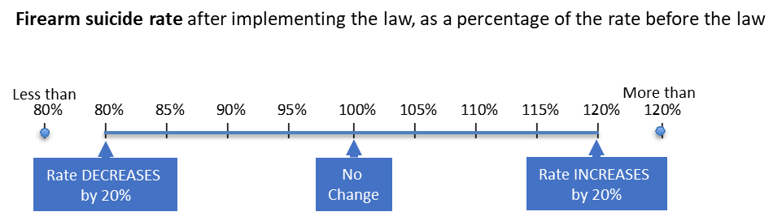

**°** No opinion [PROGRAMMER: radio button; selecting this should un-select the slider and record -1 for Q]

OPx_2. **If a state implemented *universal background checks,* how would firearm homicides change?** [The first time this question is asked, add the following sentence: This question is only about *firearms* homicides; you will be asked later about non-firearm homicide.]

With the law,the **firearm homicide rate** would be **____%** ofwhat it waswithout the law

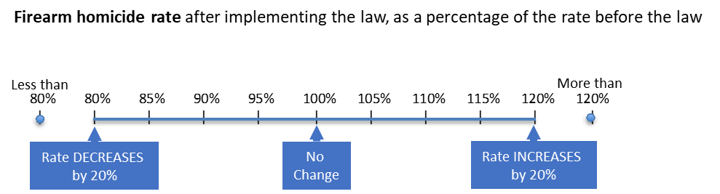

**°** No opinion [PROGRAMMER: radio button; selecting this should un-select the slider and record 999 for Q]

OPx_3. **If a state implemented *universal background checks*, how much would accidental firearms deaths change?**

With the law, the **accidental firearm death rate** would be **____%** ofwhat it waswithout the law

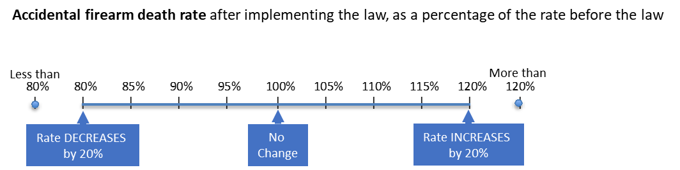

**°** No opinion [PROGRAMMER: radio button; selecting this should un-select the slider and record 999 for Q]

OPx_4. **If a state implemented *universal background checks,* how would mass shootings change?** Mass shootings refer to incidents where four or more people are killed, not including the shooter.

With the law,the **mass shooting rate** would be **____%** ofwhat it waswithout the law

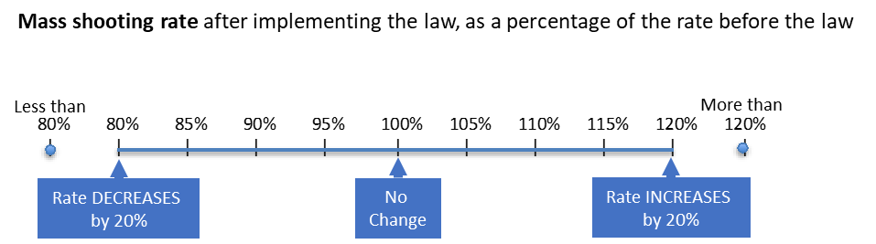

**°** No opinion [PROGRAMMER: radio button; selecting this should un-select the slider and record 999 for Q]

OPx_6. **If a state implemented *universal background checks,* how would the rate of burglary, theft, and auto theft change?**

With the law,the **property crime rate** would be **____%** ofwhat it waswithout the law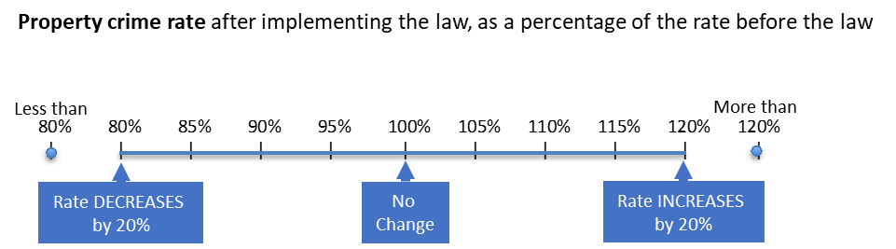

**°** No opinion [PROGRAMMER: radio button; selecting this should un-select the slider and record 999 for Q]

OPx_7. **If a state implemented *universal background checks,* how would participation in hunting and sport shooting change?**

With the law, the **hunting and sport shooting rate** would be **____%** ofwhat it waswithout the law

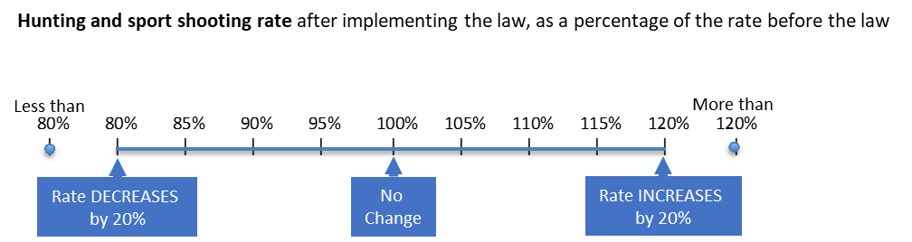

**°** No opinion [PROGRAMMER: radio button; selecting this should un-select the slider and record 999 for Q]

OPx_8. **If a state implemented *universal background checks,* how would legal acts of defensive gun use change?** This refers to using a firearm to protect oneself or others from imminent death or serious injury.

With the law, the **defensive gun use rate** would be **____%** ofwhat it waswithout the law

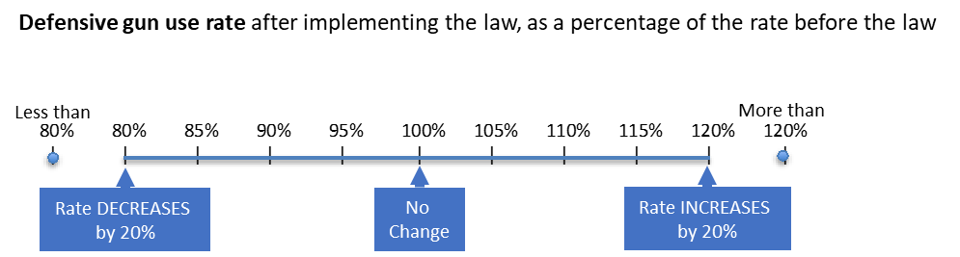

**°** No opinion [PROGRAMMER: radio button; selecting this should un-select the slider and record 999 for Q]

OPx_9. **If a state implemented *universal background checks,* how would sales of new firearms change?**

With the law, the **firearm sales rate** would be **____%** of what it waswithout the law

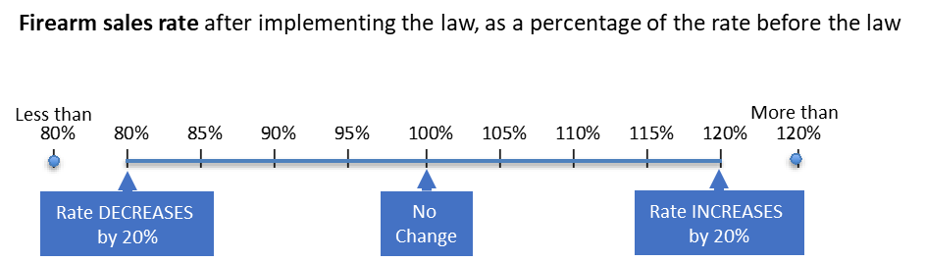

**°** No opinion [PROGRAMMER: radio button; selecting this should un-select the slider and record 999 for Q]

[Start new page, but at the top of the page show the policy definition in bold in a text box and have it remain at the top of the page for the follow-up items 10-13]

OPx_10. **How much do *universal background checks* threaten or protect the right to bear arms?**

1. Major threat
2. Moderate threat
3. Minimal threat
4. No impact
5. Minimal protection
6. Moderate protection
7. Major protection

OPx_11. **How much do *universal background checks* threaten or protect individuals’ privacy?**

1. Major threat
2. Moderate threat
3. Minimal threat
4. No impact
5. Minimal protection
6. Moderate protection
7. Major protection

OPx_13. **What is your overall opinion of *universal background checks?* Would you say *universal background checks* [is/are]…**

1. Very bad policy
2. Bad
3. Neither bad nor good
4. Good
5. Very good policy

[Questions OPX_1-OPX_13 are asked for each of the selected policies, substituting the italicized phrase associated with each policy for “*universal background checks*.”]

OP2**. *A ban on sale of “assault weapons*” *and high capacity magazines.***

**This law bans certain semi-automatic firearms with detachable magazines and other features such as pistol grips, folding stocks, or the ability to mount a bayonet. The law also bans magazines that hold more than 15 rounds of ammunition. Owners of these weapons at the time the law is passed may keep them if each weapon is registered with a state authority.**

OP3. ***A stand your ground law*.**

**This law permits a person to use deadly force without the duty to retreat when confronting a threat that could reasonably result in death or serious injury. Without this law, people outside their homes must try to withdraw from a serious threat, if possible, before using deadly force.**

OP4. ***Expanded mental health prohibitions.***

**When a judge has committed someone to an inpatient mental institution or has found them to be unable to manage their own affairs, federal law prohibits that person from having firearms. This law expands the mental health histories leading to prohibition to include people ordered to receive outpatient mental health treatment, and those involuntarily confined because a mental health professional determined they present a danger to themselves or others.**

OP5. ***Required reporting of lost or stolen firearms.***

**Firearm owners must report lost or stolen firearms to law enforcement authorities within three days of discovering the loss. Penalties for failure to report include civil or criminal liability if the firearm is used in a crime.**

OP6. ***Requiring a license to purchase or possess*.**

**This law requires a firearms license to purchase or possess a firearm or ammunition. These licenses require successful completion of a safety training course or safety test and a background check, and cost $100. They must be renewed every ten years.**

OP8. ***Required reporting and recording of firearms sales.***

**This law requires reporting all firearms sales to a government agency, including information on the firearms and who bought them. This applies to sales by both firearms dealers and private sellers. Law enforcement is permitted to retain this data indefinitely for two purposes: to trace firearms found at crime scenes, and to retrieve firearms from individuals who become prohibited possessors.**

OP9. ***A child access-prevention law.***

**This law imposes criminal penalties on firearm owners when a child accesses their usable weapon that was stored in a location where the owner should have known a child could access it.**

OP11. ***Surrender of Firearms by Prohibited Possessors*.**

**When a judge’s rulings place an individual in a class that is prohibited by law from possessing or purchasing a firearm, the judge must also determine whether that individual has firearms, and must order their surrender. This includes people convicted of a felony, misdemeanor domestic violence, and those subject to a domestic violence protective order.**

OP12. ***Firearm and ammunition taxes*.**

**This policy imposes a special $25 tax on the sale of firearms and a 25% tax on the sale of ammunition.**

OP13. ***Minimum age requirements.***

**Currently, federal law generally prohibits those younger than 18 from having a handgun, and licensed dealers are prohibited from selling them to anyone younger than 21. Those younger than 18 may have a long gun, but licensed dealers may not sell them to anyone younger than 18. The minimum age requirements policy raises the minimum age for purchase or possession of handguns and long guns to 21.**

OP14. ***Permitless carry.***

**This policy allows anyone who is at least 21 years old and not prohibited by law from having a firearm to carry a concealed weapon in public without a permit. For the questions below, assume that before adopting *permitless carry* the state required concealed carry permits that were issued to those with good moral character and sufficient reason for a concealed firearm.**

OP15. ***Requiring a ten-day waiting period to purchase a firearm.***

**This law imposes a waiting period of ten days between the purchase of a firearm and when the buyer can take possession of it. For this question, assume that the state already has a universal background check requirement.**

OP16. ***The elimination of gun-free zones.***

**Federal and some state laws prohibit carrying a firearm near schools and certain other public places. This policy allows firearms in these previously prohibited locations. For this question assume federal and state laws change in a state that previously prohibited private citizens from carrying firearms into schools, universities, government buildings and parks.**

NP1. ***Extreme risk protection orders.***

**This law authorizes police and family to request a court order prohibiting an individual deemed at imminent risk to themselves or others from possessing firearms, requiring him/her to temporarily relinquish all firearms to the police. The court can order the emergency removal of firearms for 14 days without giving the gun owner an opportunity to present evidence. Failure to surrender all firearms results in criminal penalties. Longer removals require a hearing at which the owner may present evidence they are not a high risk.**

NP2. ***Firearms prohibitions for individuals subject to domestic violence restraining orders.***

**This state law prohibits gun possession by individuals subject to domestic violence restraining orders. Each restraining order requires the surrender of firearms to police for 14 days without giving the gun owner an opportunity to present evidence. Failure to surrender all firearms results in criminal penalties. Longer removals require a hearing at which the owner may present evidence they are not a domestic violence risk.**

NP3. ***Arming school personnel in K-12 educational settings.***

**This policy specifically allows school personnel – other than peace officers – to carry firearms on school property. Staff members authorized to carry firearms are required to undertake at least 40 hours of initial training that covers use of force, weapons proficiency, the law, and first aid.**

NP4. ***Gun purchase limits.***

**This state law prohibits individuals who are not licensed firearms dealers from purchasing more than one handgun within a 30-day period. All private and dealer sales are reported to a state agency that flags individuals who have purchased more than one handgun in a 30-day window. It is a crime for both seller and buyer to complete the sale if this check fails. All records of sales are destroyed after 60 days.**

NP5. ***State prosecution of prohibited possessors seeking firearms.***

**This state law criminalizes attempted purchase of firearms by individuals prohibited by law from possessing a firearm. It also funds personnel who are tasked exclusively with investigating and prosecuting prohibited possessors who make false statements on state or federal forms when attempting to acquire a firearm.**

[The next questions each appear on separate pages]

The next questions ask about some of the indirect effects that firearm policies may have on non-firearm deaths.

ME1. Gun laws that successfully prevent firearm homicides may indirectly increase or decrease non-firearm homicides. Preventing firearm homicides could INCREASE non-firearm homicide if some murderers substitute other weapons for firearms. Preventing firearm homicides could DECREASE non-firearm homicides by preventing cycles of violence, or by freeing up police enforcement resources.

If 100 firearm homicides were prevented, how would this change the number of non-firearm homicides?

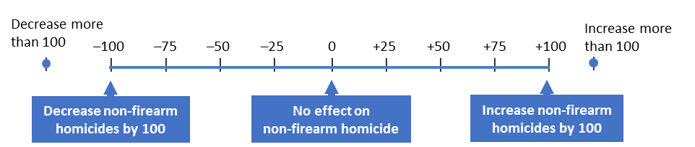

**°** No opinion [PROGRAMMER: radio button; selecting this should un-select the slider and record 999 for Q]

ME2. Gun laws that successfully prevent firearm suicides may indirectly increase or decrease non-firearm suicides. Preventing firearm suicides could INCREASE non-firearm suicides if some of those individuals switch to other means of suicide. Alternatively, preventing firearm suicides could DECREASE non-firearm suicides if suicides are contagious (i.e., each suicide puts others in the community at increased risk for dying by suicide).

If 100 firearm suicides were prevented, how would this change the number of non-firearm suicides?

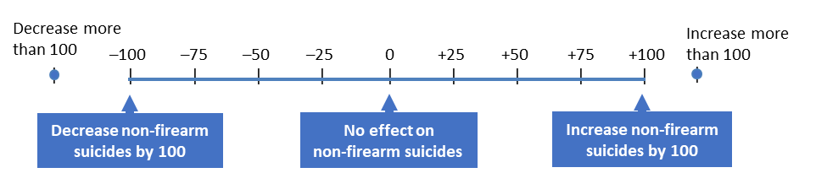

**°** No opinion [PROGRAMMER: radio button; selecting this should un-select the slider and record 999 for Q]

[The next questions appear on a separate page]

The next question asks about the effects of legal firearm ownership on homicide risk for different groups.

Q_RISK. Ownership and homicide risk.  **Compared to not owning a handgun, how much would an average person’s risk of being murdered change if they legally acquired a handgun?** Having the gun could affect homicide risk through protective effects, escalation of conflict, or the use of the gun itself in a homicide.

Q_RISKa. **Risk of homicide for the legal gun owner would be ___% the risk if they had not acquired the gun**

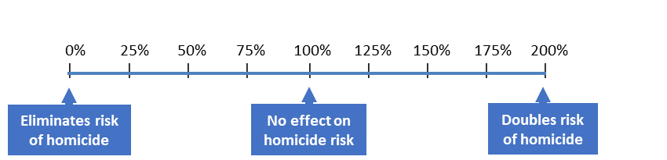

Q_RISKb. **Risk of homicide for the spouse/partner living in the household of the legal gun owner would be ___% the risk if their spouse/partner had not acquired the gun**



Q_RISKc. **Risk of homicide for a child living in the household of the legal gun owner would be ___% the risk if the person had not acquired the gun**



16. **Listed below are organizations selected because they have taken public positions on firearms policies and represent diverse perspectives on those policies. Please indicate how similar your own views on firearms policies are to those of each organization. If you are unfamiliar with an organization’s positions, mark “Not Sure.”**

[Present list in randomized order for each participant. Use the following response scale for each]

|  |  |  |  |  |  |  |  |
| --- | --- | --- | --- | --- | --- | --- | --- |
| Very different | Mostly Different | Slightly different | Slightly similar | Mostly similar | Very similar |  | Not Sure |

1. The National Rifle Association OS1
2. Gun Owners of America OS3
3. The Brady Campaign to Prevent Gun Violence OS6
4. Everytown for Gun Safety OS7

17. **Which of the following best describes your relationship to gun policy (choose all that apply):**

[Present list in randomized order for each participant.]

1. Professional researcher/scientist P1
2. Policy analyst P2
3. Policy advocate P3
4. Interested layperson P4
5. Government official P5
6. Congressional staff member P6

18. **If you have comments or clarifications you would like us to consider, please provide them here.**

[Insert comments box- allow 2000 characters]

19. IF OFFER INCENTIVE = 2, SKIP TO END

IF OFFER INCENTIVE = 1: Would you like to receive the $50 Amazon gift card?

1. Yes
2. No 🡪 GO TO END

20. IF EMAIL KNOWN: We have your email listed as [EMAIL]. Is this the correct email to use to send the gift card?

a. Yes 🡪 GO TO END

b. No 🡪 To what email address should we send your gift card? ____________________ ]

[IF EMAIL IS NOT KNOWN: To what email address should we send your gift card?

__________________________________ ]

END. Thank you very much for your assistance.